Wirral Direct Payments

Step by Step Guide to your

Pre-paid Card (PPC) Account

Table of Contents

- Contacting Prepaid Financial Services (PFS)
- Card Creation Page 2
- Card Activation Page 2
- Telephoning PFS Page 3

- Logging Onto Your Online Account Page 4

- Online Account Details Page 9

- Transferring Balance Of Old Direct Payment Account Page 10
To Your New PPC Account

- Paying Your Client Contribution/Top Up Page 11
Onto Your PPC

- Viewing Your Online Transaction History Page 12

- Payment Request Online Form Page 13

- Paying An Agency/Support Service Page 15

- Paying Your Personal Assistant(s) Page 16

- Inland Revenue Payments Page 17

- Uploading Supporting Documentation Page 18

- Contact Us Page 20

- Prepaid Financial Services (PFS)
Card Creation
The Direct Payments Team will authorise PFS to create your prepaid card.
During this set up we will give them the information needed to create and send the card out to you.
- Name and address of the account holder
- Telephone number/ email address
- And most importantly the cardholders date of birth
You should receive your card within 10 working days after creation. If your card does not arrive within this period we advise you to:-
- Contact your Direct Payments Advisor who will check that the card has been issued
- Contact PFS on 02071270754 to advise that the card has been mislaid in the post
- PFS will cancel the mislaid card and send you a new one out

Activating your card
You will receive your card and letter from PFS advising you how to activate your account.
There will be a telephone number for an INTERACTIVE VOICE RESPONSE (IVR), this allows PFS’s computer to communicate with you using your voice or telephone keys.

To activate your card you need to call one of the IVR lines below and select option 1, Retrieve your PIN
020 3327 1991
020 3468 4112
020 7183 2248
(Lines are available 24 hours a day; local charges apply)

You will be asked for the long card number on the front of your prepaid card and also the cardholder’s date of birth as a security question.

You will be allocated a PIN number by the automated system which you need to keep safe. This number is needed to access your online account.

Your account is now active.

Forgotten Pin Number
If you cannot remember your PIN number then you can retrieve it by calling the numbers above.

Please be aware that your card will be blocked if you incorrectly enter your PIN number 3 times in succession. To unblock your PIN, contact PFS Customer Services.

You can use the IVR line to
- Activate your card select option 1
- Recall your PIN number select option 1
- Check your bank balance select option 2
- Report your card lost or stolen select option 3

Telephoning PFS

We understand that not everyone will be comfortable using the internet; there is a facility to telephone and speak with a customer service representative.

The customer service representative will go through a series of questions to confirm your identity.

By contacting the customer services representative you are able to:
- Check your account balance
- Make a payment
- Make all general enquiries in relation to your prepaid card

Call the customer services team on
0207127 0754
8am to 9pm: Monday to Friday
(Local Call charges apply)

- Logging Onto Your Online Account

You can access your PFS prepaid card account from any device that has an INTERNET CONNECTION
- Computer
- Tablet / Kindle
- Smart phone

Go to www.prepaidfinancialservices.com, once open click on card holder login in the top right
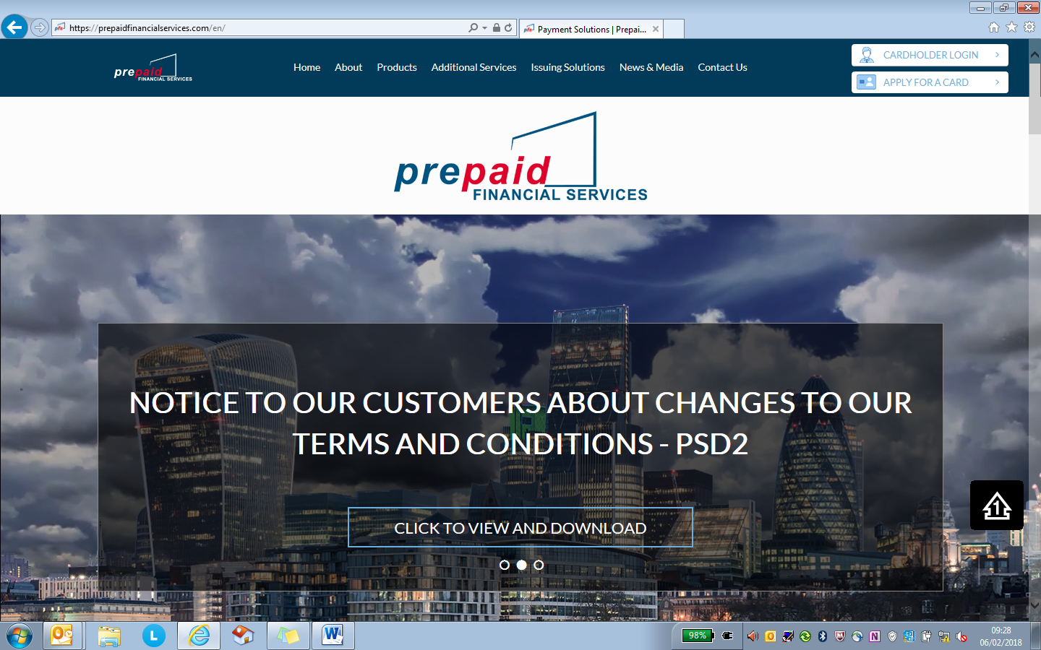

Click on Council/NHS Cardholders
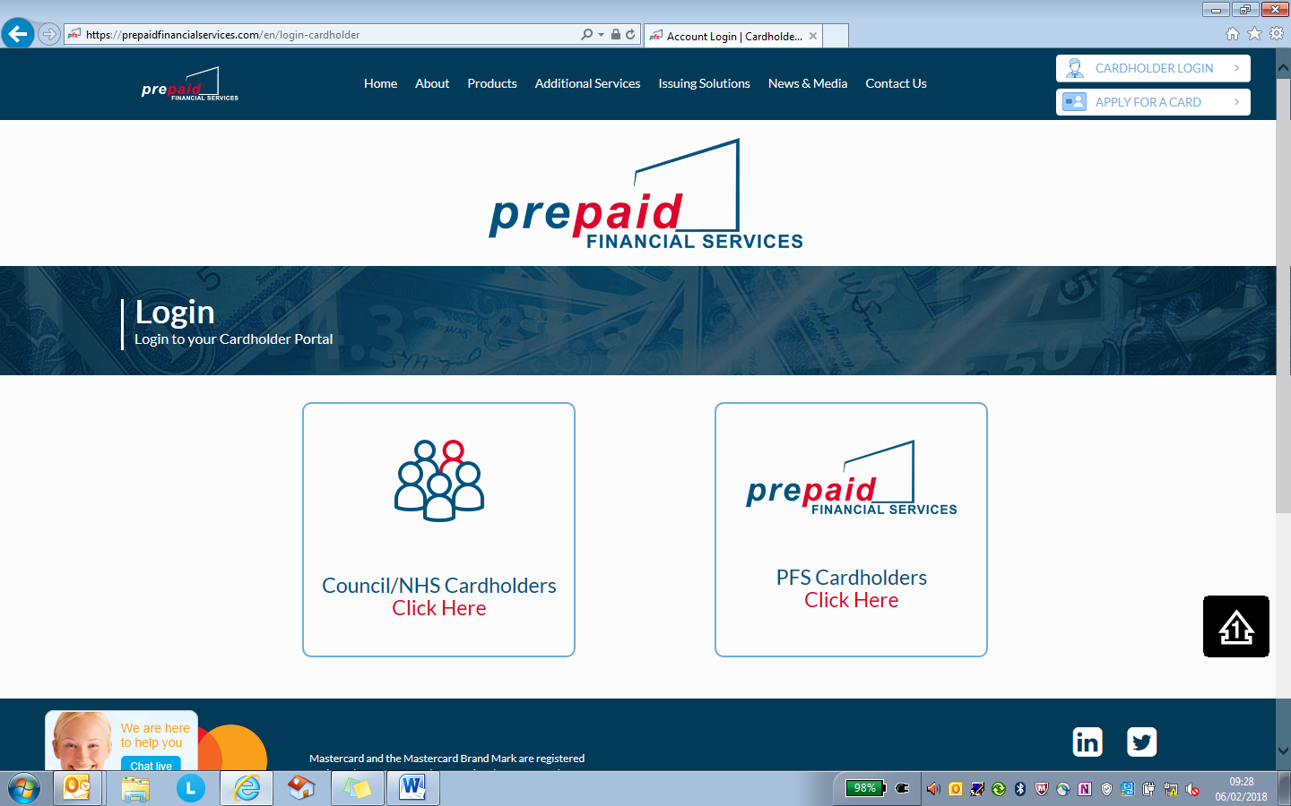

Once you find the list of Local Authorities please select Wirral.
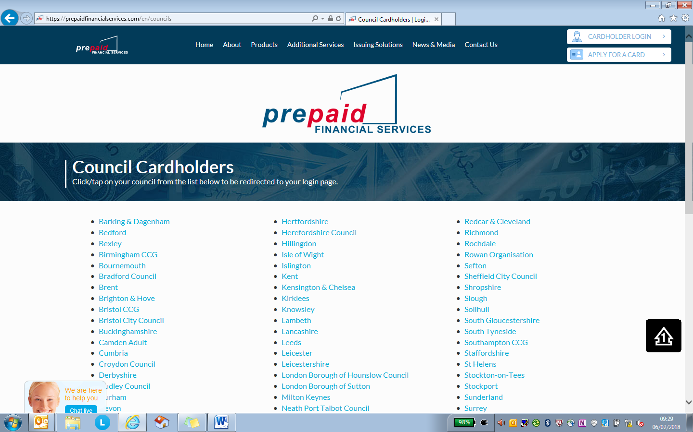

Click on I do not have a username/password and follow instructions
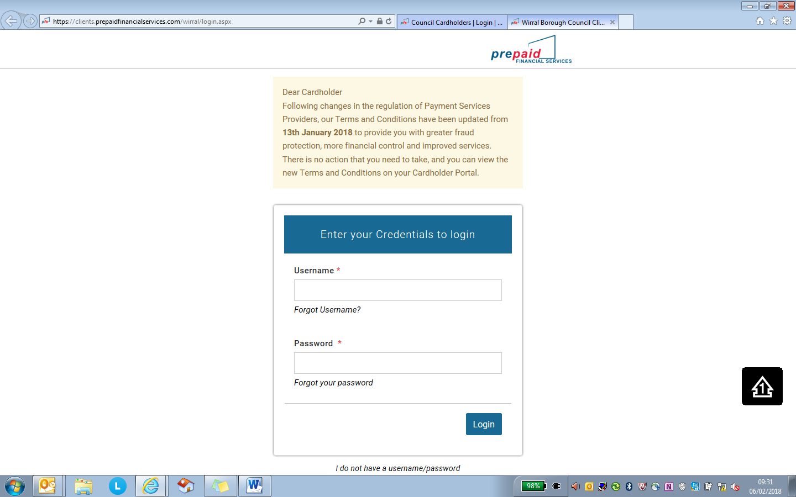

You will need to register you card, you will need to have your long card number

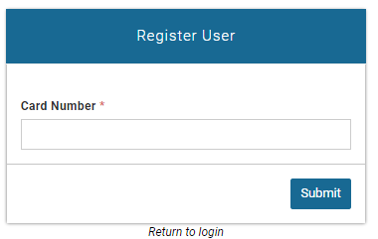

Once you have clicked on this link, it will bring up the following screen where you will need to enter your 16 digits card number. Once you have entered your card number, you will need to click on Submit.
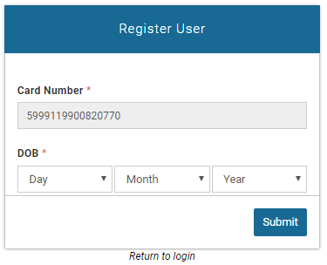
You will then need to enter your date of birth as registered on their account.

Once the data has been verified against your account, you will then be asked to set up a username, password and to choose a security question and answer on their account.
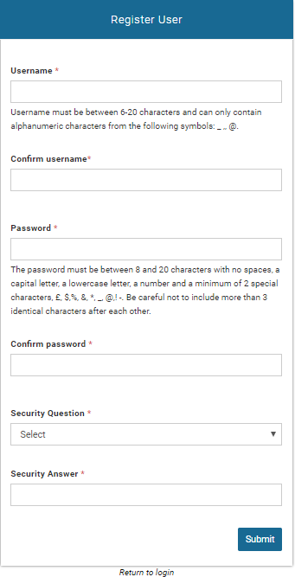
These details will then be used for retrieval of username or password if ever forgotten. When you have registered, the following confirmation message will appear:
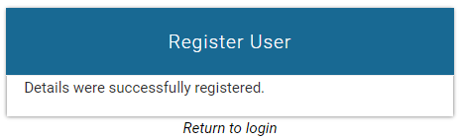

Forgotten details such as password and username can be retrieved by clicking on either the Forgot Username link or the Forgot Your Password link. In both cases, you will see the following screen:
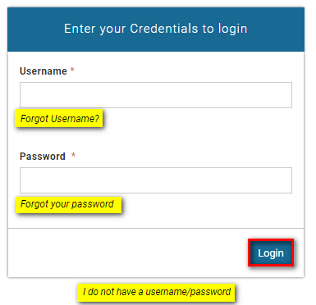

- Online Account Details.

Once you have logged in you will see the account details page, from here you can view your balance, card number, expiry date and address registered to the card.

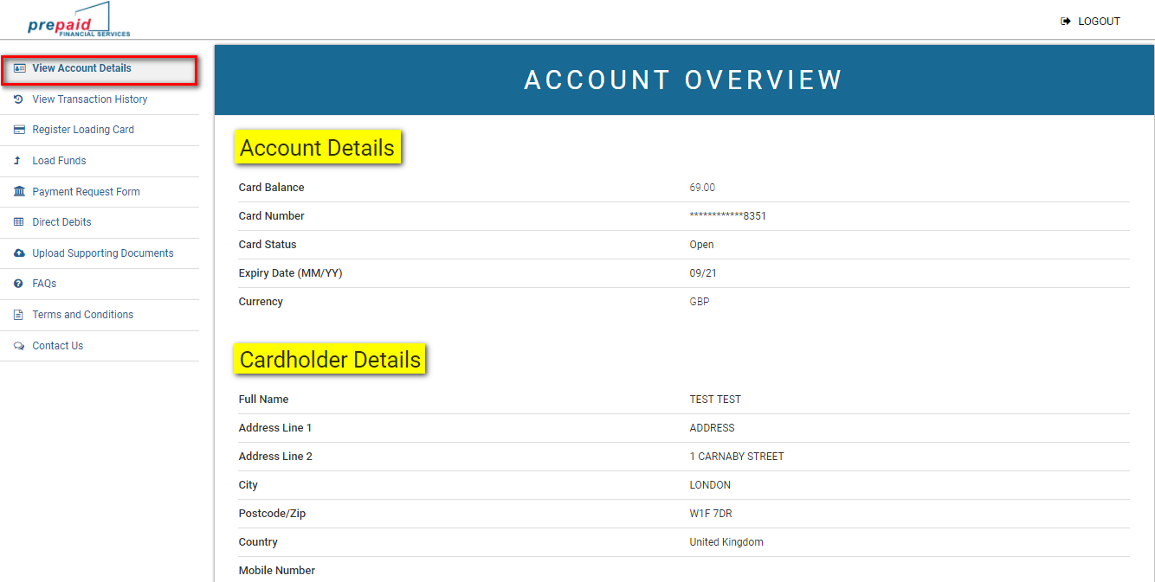
- Transferring The Balance Of Your Old Account To Your New PPC Account
Once you have confirmed that all transactions have cleared from your direct payments bank account, you must then transfer your final balance to your prepaid card account.

You will need to provide your direct payments bank with your prepaid card account details.

Account Name: Pre-paid Financial Services

Bank Name: Barclays
City International Operations 200
St Swithins House
St Swithins Lane
London EC4N 8AS

Sort Code: 23-75-24
Account number: This is the 8 digit number on your prepaid card

Reference: Balance Transfer

Inform the bank that you wish to transfer the balance of your direct payments account to your new prepaid card account.

After a few days, check that your balance has transferred correctly by logging in online or ringing PFS direct.

- Paying You Client Contribution Onto Your Prepaid Card

You will need to advise your own personal bank that payments need to be made on a regular basis onto your prepaid card, by setting up a standing order. The details below can be found online in ‘load funds’ on the prepaid card account.

You will need to provide your current bank with your prepaid card account details.

Account Name: Pre-paid Financial Services

Bank Name: Barclays
City International Operations 200
St Swithins House
St Swithins Lane
London EC4N 8AS

Sort Code: 23-75-24
Account number: This is the 8 digit number on your prepaid card

Reference: Client contribution

- Viewing Your Online Transaction History.

By selecting view transaction history the transactions made within the last 30 days will appear, if you need to view transactions older than this you can amend the dates at the bottom and select get history.

The transactions will then appear above the date range, you can also generate a PDF statement.

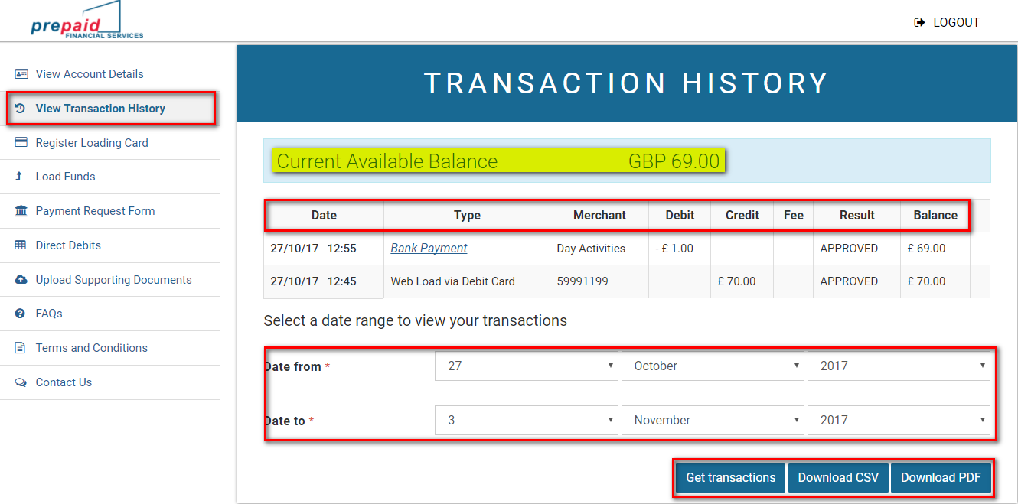

- Payment Request Online Form

The payment request form makes it easier for you to make payments via your Prepaid Card Online.

You need to select ‘make a one off payment’

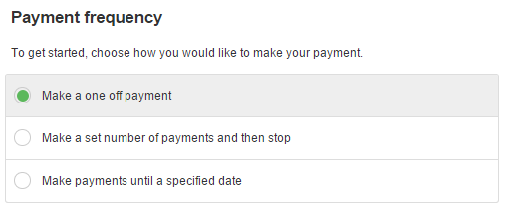

To make a payment you will need:
- Payees name
- Payees account number
- Payees bank sort code
- Invoice/receipt or employee pay slip

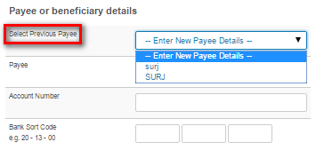

The Payee details only need to be input once as they will be saved for future use.
Select the Payee name from the drop down menu

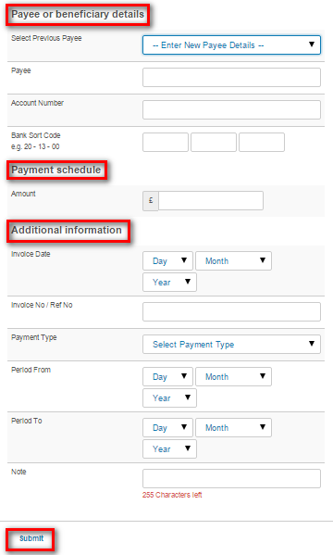
Payment schedule
Input the amount to be paid as per the employee payslip or invoice.

Additional Information
- Invoice date / payroll pay date
- Invoice Number / payroll week number
- Payment Type – use the arrow for a drop down menu
- Period from / Period to – from invoice or payroll
- Note – any additional relevant information.
Submit
Once you have pressed the submit button, it will ask you to confirm the transaction.
Check the details are correct and confirm. You will receive a message to say that your payment has been successful.

- Paying An Agency/Support Service

You will need to check with your agency/support service what would be their preferred payment method. This can be done:

- Online via www.prepaidfinancialservices.com/wirral and log into your account. see Payment Request Form above

- Contact the agency directly to make a payment over the telephone by providing them with your card details. (Please check to see if there is a charge for this method)

- Contact PFS directly who will assist you in making a payment, you will require the agencies bank account number and sort code.

- Paying Your Personal Assistant(S)

You will need to obtain the bank account information for your personal assistant.

Payment can then be made either:
- Online via www.prepaidfinancialservices.com/wirral and log into your account. see Payment Request Form above

- Contact PFS directly who will assist you in making a payment.

If you are experiencing difficulties making payment, then contact your Direct Payments Team who can assist you.

The Team can talk you through making the payment online and in some cases we are able to make the payment on your behalf by logging into your account.

- Inland Revenue Payments
Payments must be made to HMRC by logging onto your account online via

www.prepaidfinancialservices.com/wirral

Set up a one off payment on the payment request form with these details

Account Name HMRC Cumbernauld
Account Number 12001039
Sort Code 08-32-10

YOU MUST ENSURE THAT YOUR ACCOUNTS OFFICE REFERENCE NUMBER IS INPUT AGAINST THE INVOICE NUMBER ON THE REQUEST FORM.

Without this number, your payment will not be allocated against your account and you could be charged interest for non-payment. You can find your accounts office number on the front of the letter sent from the Direct Payments Team.

Do not make a payment through the HMRC website / telephone service as you will be charged a 1.4% fee.

- Supporting Documentation

When you have made a payment from your Prepaid Card Account, you will need to provide a copy of the payment document to the Direct Payments Team for audit purposes. This could be
- An agency Invoice
- A Self-employed carer invoice
- An employee timesheet
- A copy of your insurance certificate

You can send the documents by
- Uploading the document onto the prepaid card system (see below)
- Email to dassdirectpayments@wirral.gov.uk
- Post to
Client Finance Support Team
Po Box 290
Brighton Street
Wallasey
Wirral
CH27 9FQ

Uploading the documents onto the prepaid card system

You will need to have a clear and detailed copy of the document in a computer format. You can do this by:
- Scanning a copy of the document
- Taking a clear photograph on your tablet / smartphone
- Asking your care provider to email you a computer version.

Save a copy of your document that you have paid into your documents library on your device.

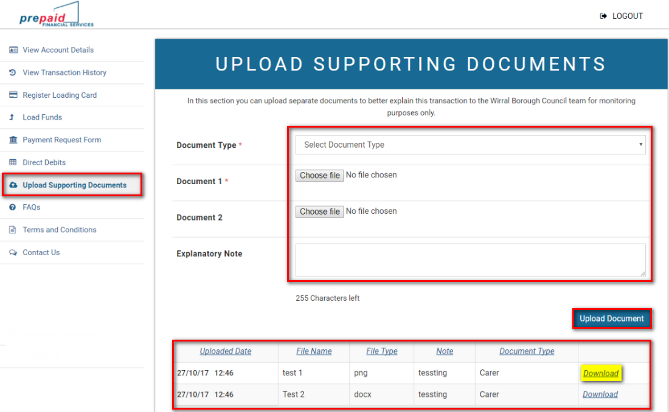

Go into the upload supporting documents tab on the online account as above

First you must select the document type you want to upload, click on choose file then it will bring you to your stored documents, double click on the relevant document and upload.

If you are having difficulties with uploading your documents, please contact the Direct Payments Team for further support.

- Contact Details
For help and support contact your Direct Payments Advisor or alternatively you can find contact details on your online account
