REMOTE TRAINING FAQS FOR PROVIDERS
FAQ | ANSWER
How will remote courses be delivered? | Some will be delivered using Microsoft Teams but others will use platforms like Zoom. Full instructions on how to access the platform will be sent round before the session. For some courses you might need to do some work or reading beforehand.
What equipment will I need? | A computer, tablet or smartphone – most already have microphones and cameras already installed. A printer would be helpful to print some course documents but should not be essential.
Do I need an email address? | Yes and it will need to be recorded on Learning Zone so trainers can use it to invite delegates to the session. Instructions for checking and changing your email address on Learning Zone are below. If your staff don’t access the Learning Zone themselves (i.e. managers book courses on their behalf) we can update email addresses for them. Just contact awft@doncaster.gov.uk with staff names and correct email addresses.
Where do I do my training? | You can access this together with colleagues at your workplace or from home using your own device; whatever you and your employer agree.
How will I get my certificate of completion. | These will either be emailed out after the session or you will be able to access them on Learning Zone as you do for e-learning courses, depending on the type of course you are attending.
How do I book on? | On Learning Zone as usual. You will only be able to book on until a couple of days before the course runs so trainers can prepare (i.e. make sure all email addresses are valid and circulate any joining instructions, handouts or pre-learning you may need to do.). If there is space and you do need to book on closer to the course start date please email awft@doncaster.gov.uk.
Will any courses be recorded? | Courses will not be recorded.

HOW TO CHANGE YOUR EMAIL ADDRESS ON LEARNING ZONE
- Once you have logged into your account, click the icon in the top right corner of the person, and then click on profile
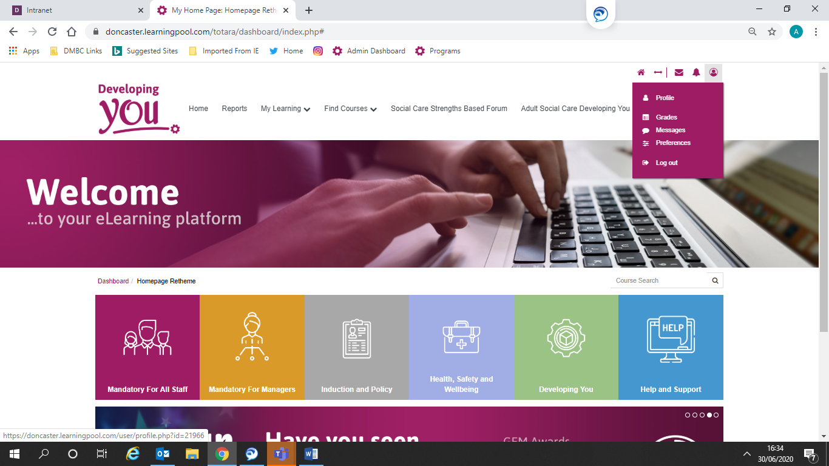
Then click on edit profile underneath user details
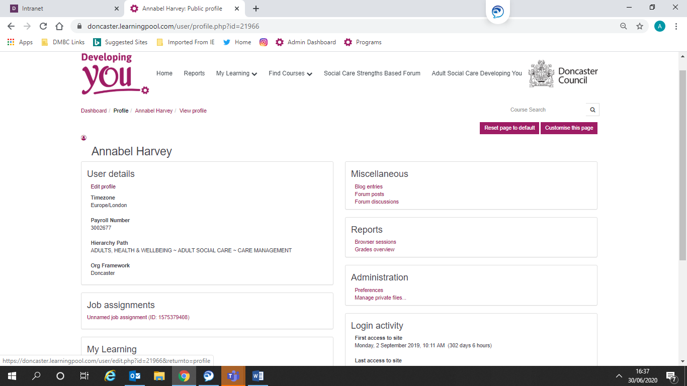

Enter your email address

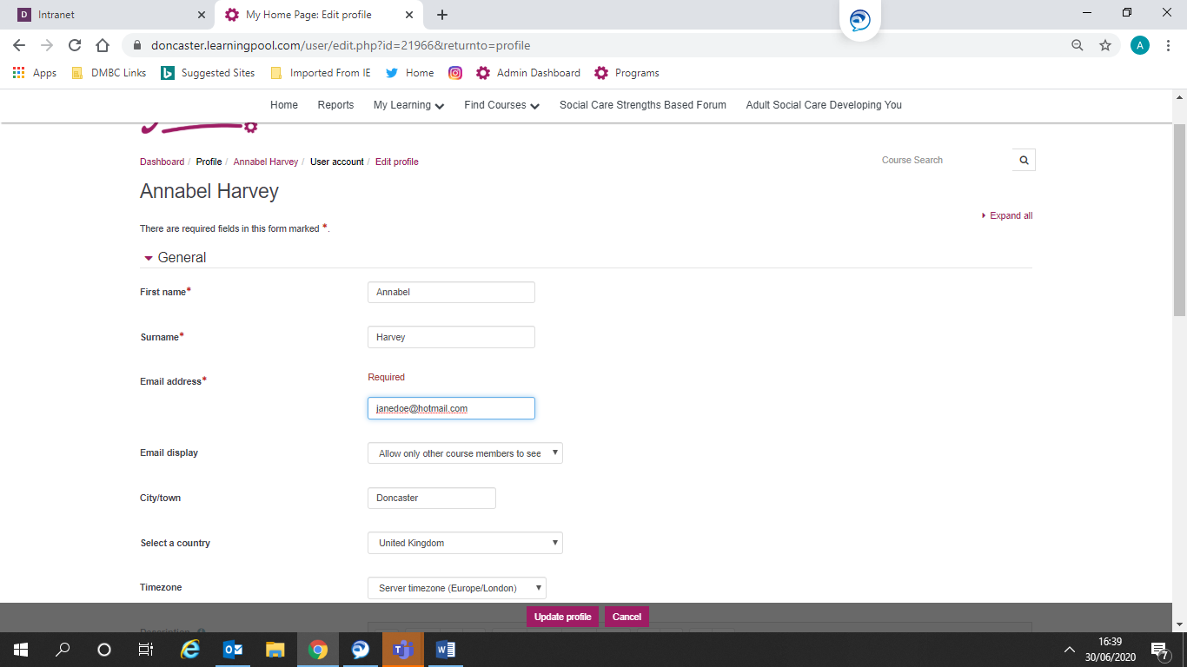

Click update profile
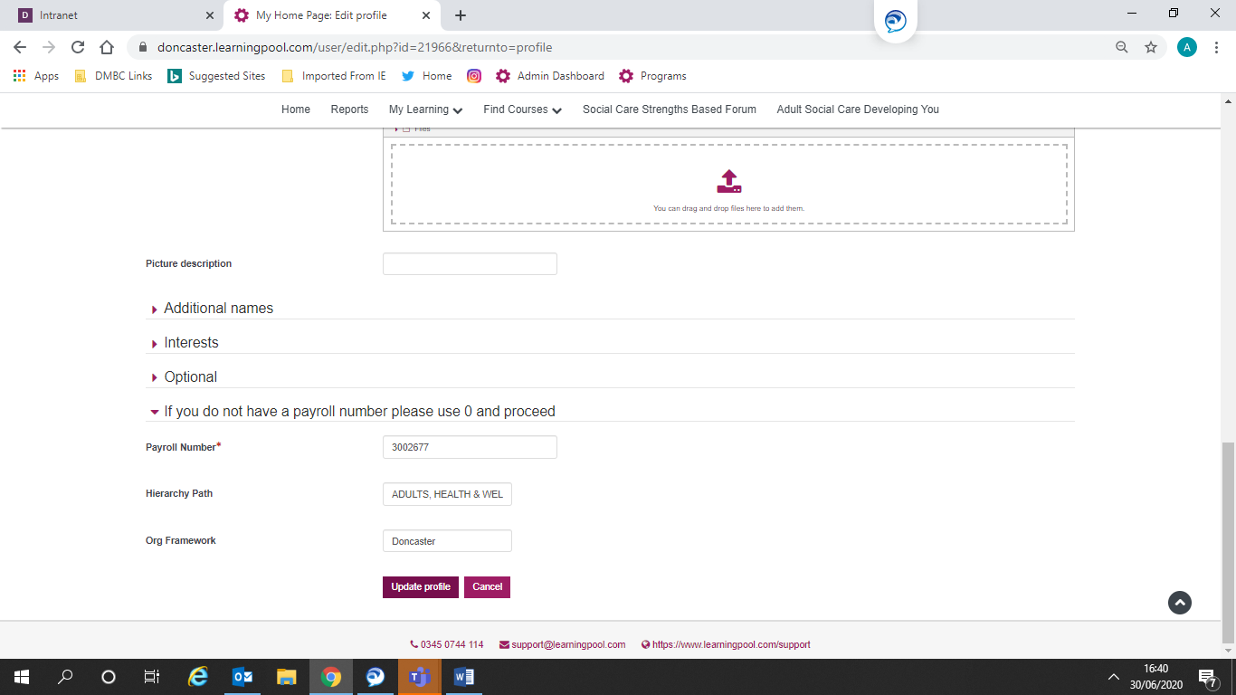

A link will then be sent to your updated email address for you to follow and confirm.

