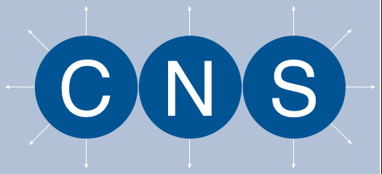

*Community Navigator Services CIC. is a local user-led organisation dedicated to sparking conversations and helping people work together in new and creative ways to achieve better lives.*

# *Come and join us at the*

Better Lives Alliance

© Community Navigator Services CIC. Company Number: 8540747

The Better Lives Alliance — creating better relationships, better opportunities, more control over our futures…

The Better Lives Alliance is a new, young, and energetic alliance of Personal Assistants, Individual Employees, and others interested in the role of Personal Assistant. Our aim is to make all our lives better by coming together, pooling our skills and knowledge, and learning from our individual experiences. We want to work together to create better relationships and opportunities. We want to explore how you create more control over your lives and futures. It is still very early days so this is your chance to join in and help us create something new and special.

Please come and meet us and chat about ways forward. We can share ideas and stories; we will discuss how the Alliance can help all of us, and how we can all help the Alliance.

If we talk and work together we can achieve more creative solutions to the challenges we face.

Your ideas and voices can help us work together in new ways. We know that these are difficult times and we need to find new and exciting ways of working — so let’s start!

You can help us do something quite wonderful…

***We are on Facebook! The Better Lives Alliance***

Come and have a virtual chat and a cuppa! Let’s see how we can support each other living in these exceptional times and circumstances. But remember these are TEMPORARY!

[bla@communitynavigatorservices.org](mailto:bla@communitynavigatorservices.org)

We do hope you can join us. It would be great if you can this is our way of Weathering the Storm.