|  |  |
| --- | --- |
|  | Adult Social Care  Salford Royal NHS Foundation Trust,  Stott Lane,  Salford  M6 8HD  Telephone:0161 631 4777  E-mail:social.services@salford.gov.uk |

Dear

**Personal Budgets during the COVID-19 period**

We are contacting everyone who uses Direct Payments to pay for their care, to explain some changes we have introduced and to give you some information about PPE and testing for the Coronavirus.

If you use a care agency, then you should read the first section called Making alternative arrangements. If you employ your own personal assistants (PAs), then you should read the whole letter.

## Making alternative arrangements

If you need to make alternative arrangements for your care as your normal care workers are unable to help you as a result of Covid-19, please contact Adult Social Care on **0161 631 4777** or [**social.services@salford.gov.uk**](mailto:social.services@salford.gov.uk) and explain that you need to make alternative arrangements.

We will reimburse you for the cost of any alternative arrangements, on top of your normal direct payment amount. This will allow you to continue paying your existing carers and ensure you are not out of pocket for the costs of any alternative arrangements.

During this period, an alternative arrangement may be employing someone who lives with you to provide the same support, as this can reduce your risk of catching the virus.

If you need to make significant changes to your care or your needs have changed, please contact us as usual.

If you have any other issues in relation to your Direct Payments at this time, please contact Penderels by email [**salford@penderelstrust.org.uk**](mailto:salford@penderelstrust.org.uk)**,** telephone**: 0161 743 3592** or by searching the website:**www.penderelstrust.org.uk**

## Employing your own PAs – Personal Protective Equipment (PPE)

As an employer, you will be aware of your responsibility for the health and safety of your staff. We have also provided current guidance at the end of this letter. Please be aware that the guidance is being updated regularly.

You and your PA can also read about staying safe and using PPE correctly at:

* [**www.gov.uk/government/publications/covid-19-personal-protective-equipment-use-for-non-aerosol-generating-procedures**](http://www.gov.uk/government/publications/covid-19-personal-protective-equipment-use-for-non-aerosol-generating-procedures)

If you do not have internet access, we will arrange for you to receive a paper copy of the information.

We can reimburse you for the cost of extra PPE that you are using because of Covid-19. Please keep your receipts and complete the attached form. You can either email the completed form to [**SCO.Covid-19-Finance@srft.nhs.uk**](mailto:SCO.Covid-19-Finance@srft.nhs.uk) or post it to

Matthew Greene, Finance Department  
Turnpike House, 631 Eccles New Road, Salford M50 1SY

Please make sure to include your receipts.

If you are running out of PPE for your PAs and are unable to get more supplies, the council’s infection control team may be able to provide some until you can get more. You can contact them through the adult social care contact team.

Providing you with additional PPE does not change the employment situation of your PA, with you remaining the employer.

## Employing your PAs – testing

If you or your PA believes that they have symptoms of Covid-19, then you should follow the government guidance around isolation. This will also affect any members of your household or your PA’s household.

We can arrange for your PA (or members of their household) to be tested, in order that they can either isolate themselves from you, or come back to work as quickly as possible. **The test should be within three days of symptoms and must be no more than five days after the person developed symptoms.**

To request testing, type this into your internet browser:

<https://contactus.salford.gov.uk/?formtype=SWAB_CALL>

If you do not have internet access, telephone 0161 793 3585.

## Employing your PAs while they are sick or self-isolating

We will continue to make direct payments to you at the usual value throughout this period. If you receive less care as a result of Covid-19, we will not lower the amount paid to you. This includes any reduction in care because your PAs have been off sick or unable to get to you.

In return for the consistent payments we can provide to you, we would ask that you continue to make payments to your PAs as you usually do, even if they have provided less support to you. This should help to ensure that your care is not disrupted in the longer term and allow you to retain your current arrangements.

We are currently expecting this arrangement to remain in place until 31/07/2020. If there are any changes to this, we will let you know.

## Employing your PAs – other useful information

As well as Penderels Trust, the Skills for Care website contains lots of useful information, including a template letter stating that your PA is akey worker. Your PA should also look at this website, as it includes information for them too.

## www.skillsforcare.org.uk/Employing-your-own-care-and-support/Information-hub

## What to do if your care and support is not working, because of coronavirus

If you are worried about your care and support, or someone who normally provides your care has become ill and isn’t able to look after you, call:

**0161 631 4777** or email [**social.services@salford.gov.uk**](mailto:social.services@salford.gov.uk) and quote: **COVID 19**

## Spirit of Salford Helpline and useful information

Lots of organisations and people in Salford are pulling together to help and have set up a **Spirit of Salford helpline.**

If you have questions or worries about

* Food shopping.
* Getting essential medication.
* Getting fuel (if you are on a pre-paid meter for gas or electric).
* Looking after pets. and how you will manage, please call

0800 952 1000, Monday to Friday 8.30am - 6.00pm or [**www.salford.gov.uk/spiritofsalford**](http://www.salford.gov.uk/spiritofsalford)

## Domestic abuse and keeping safe

The order to stay at home can cause anxiety for those who are experiencing or feel at risk of domestic abuse. Domestic abuse is more than physical violence. It can also include, but is not limited to: coercive control and ‘gaslighting’, economic abuse, online abuse, verbal abuse, emotional abuse, sexual abuse.

If you are in immediate danger, call 999 and ask for the police.

If you are in danger and unable to talk on the phone, call 999 and then press 55. This will transfer your call to the relevant police force who will assist you without you having to speak.

### National Domestic Abuse Helpline

The [National Domestic Abuse Helpline](https://www.nationaldahelpline.org.uk/) provides guidance and support for potential victims, as well as those who are worried about friends and loved ones. You can call for free and in confidence, 24 hours a day on 0808 2000 247.

### Keeping safe

If you are self- isolating, try to use family, friends, neighbours and existing trusted community and voluntary groups.

If you’re not sure about an offer of help, ask the person to leave details and talk to someone you trust about it. Don’t give out bank details or PIN numbers. Don’t invite volunteers into your home or offer payment in cash or goods. If the situation feels wrong or it seems too good to be true, stop and think about it.

If you are worried that someone is trying to take advantage call Salford’s Adult Social Care service on 0161 631 4777 or email [worriedaboutanadult@salford.gov.uk](mailto:worriedaboutanadult@salford.gov.uk)

* Adult social care contact team: [social.services@salford.gov.uk](mailto:social.services@salford.gov.uk); 0161 631 4777
* Penderels Trust: www.penderelstrust.org.uk; [salford@penderelstrust.org.uk](mailto:salford@penderelstrust.org.uk); 0161 743 3592
* COVID-19 Testing: covid19.testing@salford.gov.uk; 0161 793 3585
* Skills for Care: [www.skillsforcare.org.uk](http://www.skillsforcare.org.uk) (search for information hub)
* Government advice: www.gov.uk/government/publications/coronavirus-covid-19-guidance-for-people-receiving-direct-payments/coronavirus-covid-19-guidance-for-people-receiving-direct-payments

Yours sincerely



Cath Gormally

|  |  |  |  |  |  |  |  |  |  |  |
| --- | --- | --- | --- | --- | --- | --- | --- | --- | --- | --- |
| **PPE Costs for People Using Direct Payment** | | | | | | | | |  | |
|  |  | |  | |  | |  | |  | |
|  |  | | **Name of Person Completing form:** | |  | | | |  | |
|  |  | |
|  |  | | **Email contact details:** | |  | | | |  | |
|  |  | | **Telephone** | |  | | | |  | |
|  |  | |  | |  | |  | |  | |
| **Payee Name:** | | **Address 1** | | **Address 2** | | **Address 3** | | **Address 4** | | **Postcode** |
|  | |  | |  | |  | |  | |  |
|  |  | |  | |  | |  | |  | |
|  | **Bank Account Details** | |  | |  | |  | |  | |
|  | **Sort Code** | |  | |  | |  | |  | |
|  | **Bank Account** | |  | |  | |  | |  | |
|  |  | |  | |  | |  | |  | |
| **Date Purchased** | **Supplier** | | **Type of PPE (E.G. Masks, Gloves, Gowns etc.)** | | **Quantity Purchased (Number of Units)** | | **Total Cost (For all Units)** | | **Invoice Number / Purchase Order Number / Quote Reference** | |
|  |  | |  | |  | |  | |  | |
|  |  | |  | |  | |  | |  | |
|  |  | |  | |  | |  | |  | |
|  |  | |  | |  | |  | |  | |
|  |  | |  | |  | |  | |  | |
|  |  | |  | |  | |  | |  | |
|  |  | |  | |  | |  | |  | |
|  |  | |  | |  | |  | |  | |
|  |  | |  | |  | |  | |  | |
|  |  | |  | |  | |  | |  | |

**Salford Health Protection Team**

**Coronavirus Infection Prevention Advice Update V5, 25.04.2020,**

**This guidance has been developed to inform staff members who may be caring for individuals in a care setting or in their own home or other professionals visiting individuals regardless of their infectious status**

Staff members could be:

* Nursing and Care Home staff within all residential care settings (adults, children, learning disability)
* Staff from supported tenancies
* Social workers visiting individuals within their own homes
* Home Care agency staff caring for individuals within their own homes
* Visiting tradespeople who supply an essential service
* Environmental Health teams who could be visiting food establishments with attached dwellings (i.e., families living above premises)

**Covid -19 prevention advice for care homes and other residential settings**

* Residential settings include care homes, nursing homes and other residential settings caring for or supporting adults, children or learning disability.
* Residents should follow social distancing measures. This might include limiting movement of residents between floors, or restricting the number of residents in communal areas at any one time.
* Tissues and handwashing facilities should be available throughout your facility to enable residents to wash their hands regularly and to use tissues for any coughs or sneezes.
* It is good practice to have a COVID-19 lead on every shift.
* Management and staff should proactively ask residents about symptoms daily, do they feel well?
* In care homes and nursing homes:
  + Staff should be trained to check the temperature of residents twice a day to support the early detection of COVID-19.
  + During this pandemic all residents in care homes should be isolated, including the well residents and in those homes without an outbreak.
  + Residents in care homes should be isolated and barrier nursed for 14 days following the onset of COVID-19 symptoms (not 7 days).
  + New admissions into the care home should be isolated and barrier nursed for 14 days from admission to the home.

**Role of the Covid-19 Co-ordinator in care homes and other residential settings**

* Ensure Hand hygiene is always of a high standard.
* Ensure residents hands are washed before meals.
* Ensure residents are assessed daily (and in care homes and nursing homes, ensure that residents’ temperatures are checked 2x daily).
* Ensure isolation is working well and safely, and social distancing measures are being followed appropriately.
* Ensure staff have access to all the PPE they need.
* Ensure staff are using PPE correctly, including donning and doffing (applying and removing) it safely to ensure staff don’t contaminate themselves.
* At the start of every shift, a staff member should volunteer to demonstrate donning and doffing PPE to the team. This is good practice. Staff in homes who carry this exercise out have found it helpful and supportive.

|  |  |  |
| --- | --- | --- |
| **Home care services**  **PPE advice for services providing home care for clients that are well, confirmed or suspected COVID-19** | | |
|  | **Visiting a home to provide direct care** | **Sessional use meaning for home care providers: -**   1. You would wear 1 mask per visit to a home. 2. If you are providing care for 2 clients in the one home, you can use the same mask.   **You would not wear the same mask used to care for suspected or confirmed COVID-19 residents as those that are well.**   * The front of the mask should never be touched once fitted and when removing.   (See Notes on PPE Use at the end of this document) |
| Disposable gloves (single use) | YES |
| Disposable apron (single use) | YES |
| Fluid repellent surgical mask ( sessional use) | YES |
| Eye protection | YES* |

**COVID -19 prevention advice for homecare and other visits to households**

The following flow chart maybe useful to risk assess each individual visit

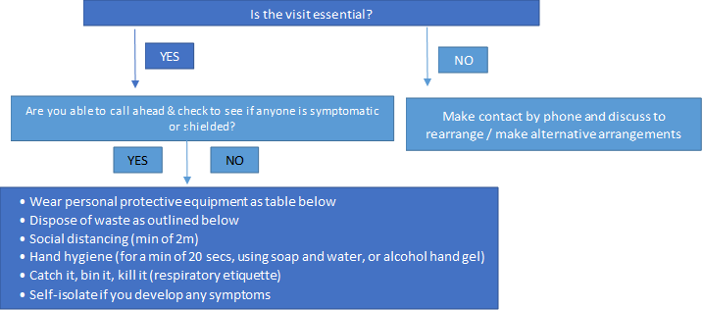

|  |  |  |  |
| --- | --- | --- | --- |
| **TABLE C: Guidance for home visits**  **PPE advice for services visiting households (not delivering direct patient/resident care)** | | | |
|  | If symptomatic, or staff are unable to triage ahead / assess | If asymptomatic (have none of the symptoms below) following triage | If someone is being shielded in that household |
| Disposable gloves (single use) | YES | NO | YES |
| Disposable apron (single use) | YES | NO | YES |
| Fluid repellent surgical mask (sessional use) | YES | NO | YES |
| Eye protection | YES* | NO | YES* |
| **Staff are advised to call beforehand to assess symptoms**:  **A well resident/client:** feels 100% well, seems themselves and not displaying any changes in behaviour or their daily routines.  **An unwell, possible case of COVID-19:** They can be displaying just one of the following symptoms **-** cough, temperature, vomiting, diarrhoea, sleeping more than usual, complaining of not feeling themselves in anyway, agitated, cold, headache **-**anything that is not feeling themselves could be a sign of COVID-19. Use all PPE including a mask.  (See Notes on PPE Use at the end of this document) | | | |

**NOTES ON PPE USE**

(1) Fluid Repellent Surgical Masks are to be worn on a single use or sessional basis. This means that masks should be changed;

* On leaving a room once you have provided sessional care of a group of residents in home.
* When they are damp
* When they are damaged
* When the person wearing the mask leaves the setting for a break (such as leaving their unit within a care home for their lunch break)
* When the person wearing the mask leaves the domiciliary setting and moves onto a new client

Fluid Repellent Surgical Masks MUST:

*Eye protection may be needed for care of some residents where there is risk of contamination to the eyes from respiratory droplets or from splashing of secretions e.g. caring for a resident who is repeatedly coughing or may be vomiting. Use of eye protection should be discussed with your manager and be informed by a risk assessment in your care home. Eye protection can be used continuously while providing care until you take a break from duties

* Be well fitted covering both the nose and mouth
* Not be allowed to dangle around the neck of the wearer
* Not be touched once put on
* Discarded as healthcare (clinical) waste
* Hand hygiene MUST always be performed after disposal

*(2) Eye Protection is to be worn on a sessional basis and when there is a risk of splashing of blood or bodily fluids

* Cover the eyes completely
* Not be allowed to dangle around the neck of the wearer
* Not be touched once put on
* Be worn once and then discarded as healthcare (clinical) waste
* Hand hygiene MUST always be performed after disposal
* Be worn if there is a risk of splashing of blood or bodily fluids

In the event that disposable eye protection is unavailable, reusable plastic goggles can be worn. These MUST:

* Cover the eyes completely
* Not be allowed to dangle around the neck of the wearer
* Not be touched once put on
* Be cleaned in between each use, using detergent wipes and then disinfectant wipes (minimum of 70% alcohol content)
* Disposable gloves and aprons MUST be worn whilst cleaning the goggles
* Hand hygiene MUST be performed once the goggles have been cleaned
* Be worn if there is a risk of splashing of blood or bodily fluids

**Supply of PPE**

You can contact the following distributors for social care to request additional PPE:

|  |  |
| --- | --- |
| Careshop - [coronavirus@careshop.co.uk](mailto:coronavirus@careshop.co.uk) | Blueleaf Care - Tel: 03300 552288, [emergencystock@blueleafcare.com](mailto:emergencystock@blueleafcare.com) |
| Delivernet - Tel: 01756 70 60 50, [kevin.newhouse@delivernet.co.uk](mailto:kevin.newhouse@delivernet.co.uk) | Gompels – www.gompels.co.uk |
| Nexon - https://nexongroup.co.uk/ | Wightman and Parrish - www.w-p.co.uk/ |
| Countrywide Healthcare - Tel: 01226 719090, [enquiries@countrywidehealthcare.co.uk](mailto:enquiries@countrywidehealthcare.co.uk) | |

If you have immediate concerns about PPE, you can contact: **The National Supply Disruption line** Tel: 0800 915 9964, [supplydisruptionservice@nhsbsa.nhs.uk](mailto:supplydisruptionservice@nhsbsa.nhs.uk). PHE NW do not hold any stores of PPE, but we are aware that supply issues have been escalated through the Ministry of Housing, Communities and Local Government through local resilience fora.

Contact at Salford City Council for emergency PPE, please email both – [beverley.wasp@salford.gov.uk](mailto:beverley.wasp@salford.gov.uk) & [deborah.blackburn@salford.gov.uk](mailto:deborah.blackburn@salford.gov.uk)

**Procedure for putting on (donning) Personal Protective Equipment**

|  |  |
| --- | --- |
| **General advice**   * Ensure health/social care worker hydrated * Ensure hair tied back * No jewellery (plain wedding band only) * Check PPE in the correct size * Keep hands away from face * Change gloves if heavily contaminated * Limit surfaces touched in the resident / individual environment * Always clean hands after removing PPE | **Action steps:**   1. Perform hand hygiene before putting on PPE 2. Put on disposable apron, tie apron at the back 3. Apply disposable facemask, ensuring it is well fitted covering both the nose and mouth (bend the metal piece in the nose to fit) 4. Apply disposable eye protection / reusable goggles ensuring the straps are secure around the head 5. Apply disposable gloves |

A video showing how to put on (don) and remove (doff) personal protective equipment has been produced:

<https://www.gov.uk/government/publications/covid-19-personal-protective-equipment-use-for-non-aerosol-generating-procedures>

**Procedure for removing (doffing) Personal Protective Equipment (PPE)**

General Advice:

* PPE should be removed in an order that minimises the potential for cross infection
* PPE is to be removed in as systematic way before leaving the resident / individuals room

The order of removal of PPE is as follows:

1. Gloves – the outsides of the gloves are contaminated and must be disposed of as contaminated waste

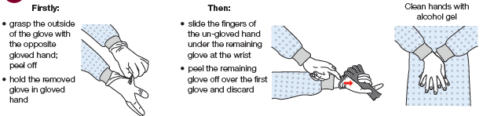

1. Remove apron by SNAPPING the neck area and **folding this onto the bottom part of the apron** (the inside of the apron is clean)
2. Grasp the front of the apron (**which is the inside of the apron),** pulling away from body, which will break the waist ties and FOLD the apron in on its self and dispose contaminated waste
3. Clean hands with alcohol hand gel / wash hands using soap and water

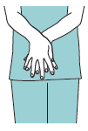

1. Eye Protection – the outside will be contaminated. Remove using both hands to handle the retaining straps by pulling away from the head and discard. If eye protection is reusable place in a receptacle or a clean paper towel and then follow the procedure below*
2. Clean hands with alcohol hand gel / wash hands using soap and water
3. Disposable facemask – do NOT touch the front of the mask as it will be contaminated
   1. Lean slightly forward
   2. Reach to the back of the head with both hands to find the straps
   3. Pull the straps away from the back of the head
   4. Break the ties , pulling the mask forward and down AWAY from the face and body
   5. Dispose as clinical waste
   6. WASH hands with soap and water (alcohol gel may be used if soap and water not available)

*Eye protection

* Clean hands with alcohol hand gel / wash hands with soap and water
* Put on clean apron and gloves
* Clean eye protection with detergent wipes followed by disinfectant wipes (minimum of 70% alcohol content)
* Place in a clean plastic bag
* Remove gloves and apron using procedure as above and discard in clinical waste
* WASH hands with soap and water (alcohol gel may be used if soap and water not available)

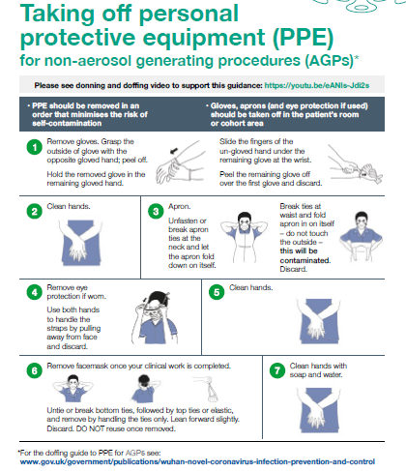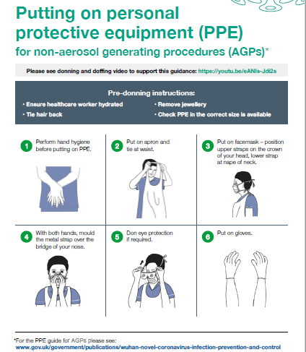

**Procedure for discarding of contaminated waste**

1. Tie a knot in the first waste bag
2. Place into a second waste bag and secure
3. Place label on the waste with date/time/Name of person who has dealt with waste
4. WASH hands with soap and water (alcohol gel may be used if soap and water not available)
5. Stored separately from other waste for a minimum of 72hrs

**Hand Hygiene**

Please ensure that all staff are carrying out appropriate hand hygiene procedures: -

* Using the hand washing technique for a minimum of 20 seconds
* They should be bare below the elbow, no hand or wrist jewellery (a plain wedding band is acceptable).
* Short nails, no varnish, no artificial nails
* Forearms to be washed when washing hands.
* Hand washing when arriving to work and leaving, before donning and after removing PPE, after using the bathroom and before eating and drinking.

**Procedure for laundering items from symptomatic / known positive COVID 19 residents**

* Any towels or other laundry used by the individual should be treated as infectious and placed in an alginate bag then a secondary clear bag. This should then be removed from the isolation room and placed directly into the laundry hamper/bag. Take the laundry hamper as close to the point of use as possible, but do not take it inside the isolation room.

When handling linen do not:

* Rinse shake or sort linen on removal from beds
* Place unused infectious linen on the floor or any other surface
* Rehandle used/infectious linen when bagged
* Overfill laundry receptacles
* Place inappropriate items in laundry receptacle
* Laundry must be tagged with the care area and date, and stored in a designated, safe lockable area whilst awaiting uplift or laundering.
* Laundry should be laundered in line with local policy for infectious linen.

Staff Uniforms / Workwear

Staff must remove their uniforms or workwear when returning home, place uniforms / workwear directly into the washing machine (do not shake or place on the floor or any other surface), do not wash with other items, on the hottest wash available for these items, preferably using a biological washing powder.

**Testing for suspected case in member of staff:**

* Staff members with symptoms or if it is a household member with COVID-19 symptoms, they can be tested. Testing ideally should be carried out in the first 3 days of onset of symptoms, no test will be carried out after 5 days of onset.   While waiting results, staff should stay at home. Results are expected within 48-72 hours.
* Staff should be off work for at least 7 days. If symptoms persist over 7 days, staff need to be symptom free for 48 hours before returning to work.
* If the household member is tested and negative, the staff member can return to work after 48 hours when their symptoms resolve.
* If the household member is positive the staff member must stay off work for 14 days. If the staff member develops symptoms during this period, they can return to work 7 days after their symptoms started or they must be symptom free for 48 hours. Further info: <https://www.gov.uk/government/publications/covid-19-stay-at-homeguidance>.
* To organise testing for your staff member, type this into your internet browser:

<https://contactus.salford.gov.uk/?formtype=SWAB_CALL>